**Functionality Description**

**For**

**[SP Movies 2.0]**

**Date: [05/02/2023]**

**Contents**

1 Document Management 3

*1.1* *Contributors* 3

*1.2* *Version Control* 3

2 OVERVIEW 4

2.1 Function Description 4

2.2 Technology 10

2.3 Development Tools and Processes 11

2.4 Interfaces and services 12

3 APPENDIX 15

3.1 Additional / Advanced features 15

3.2 Reference Links 16

# Document Management

## *Contributors*

*Details of all contributors to this document*

|  |  |
| --- | --- |
| **Function Integrated** | **Name** |
| Function #1,2,3 | Ng Cheng Wai Melvin |
| Function #4 | Kua Zi Lin |
| Function #5 | Ng Chye Yong |
| Function #6, #7 | Ng Cheng Wai Melvin |
| Various additional features/functions | Ng Cheng Wai Melvin |
|  |  |

## *Version Control*

*Changes made to this document since creation.*

|  |  |  |  |  |
| --- | --- | --- | --- | --- |
| **Date** | **Version** | **Author** | **Section** | **Amendment** |
| 01/02/23 | 1.0 | Melvin | - | Initial Creation |
| 03/02/23 | 1.1 | Kua | 2.1 | Update Function 4 Function Description |
| 03/02/23 | 1.2 | NG CY | 2.1 | Update Function 5 Function Description |
| 04/02/23 | 1.3 | Kua | 2.4 | Update Function 4 Interface & Service |
| 04/02/23 | 1.4 | NG CY | 2.4 | Update Function 4 Interface & Service |
| 04/02/23 | 1.5 | Melvin | 3.1, 3.2 | Add new sections & Tidy up document |
| 04/02/23 | 1.6 | Melvin | 2.1 | Fix minor typos |
|  |  |  |  |  |
|  |  |  |  |  |
|  |  |  |  |  |
|  |  |  |  |  |

# OVERVIEW

*A brief description of what the overall system is about from a business perspective.*

## Function Description

*High level description of what functionality the system contains (a list of the components / functionalities that have been integrated (frontend ↔ backend)).*

*This should include*

*i) a sequence diagram of the input / output between the User, Front End (i.e. the Website) and the Backend (i.e. the Server App).*

*ii) screenshots of the end to end process (i.e. what would be observed by the User)*

1. **Function #1 – Login functionality (WIP)**

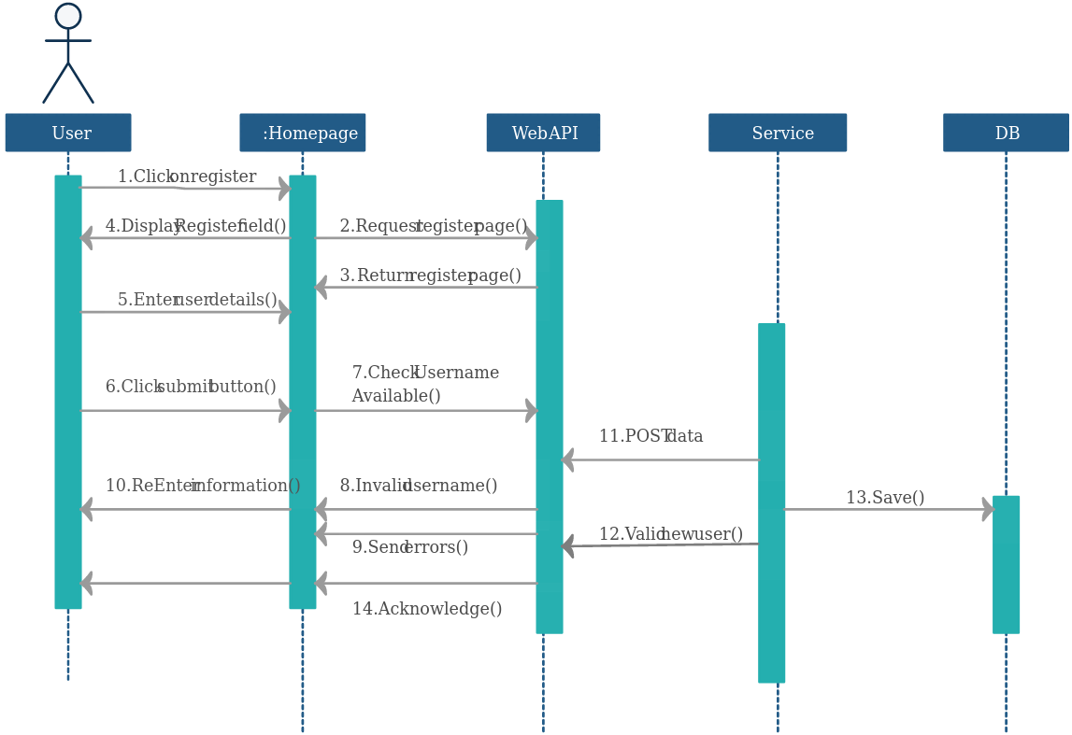

1. **Function #2 – Retrieve & Display a list of movies (WIP)**
2. **Function #3 – Update Movies (WIP)**
3. **Function #4 - Retrieve Movies and Sorting Z to A**

* Once the user is logged in, the user can use this function to retrieve the latest movies database from the server and display it in reverse alphabetical order (Z to A).



* Before Sorting Z-A:

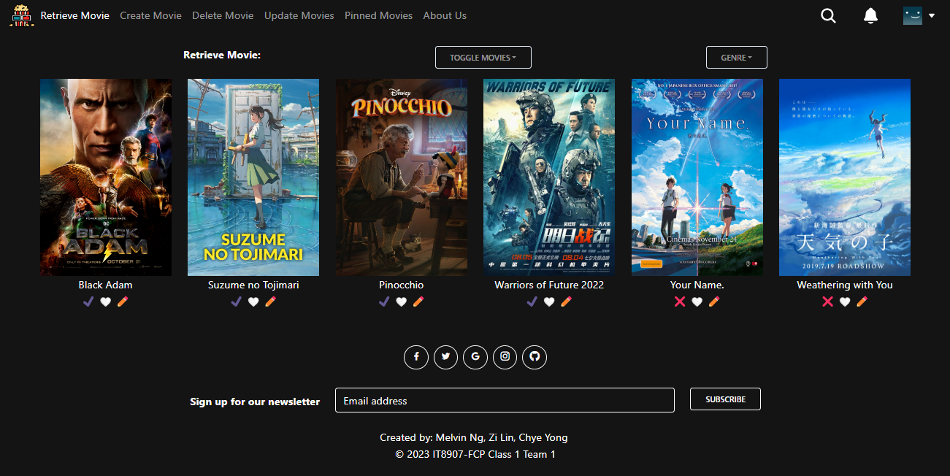

* 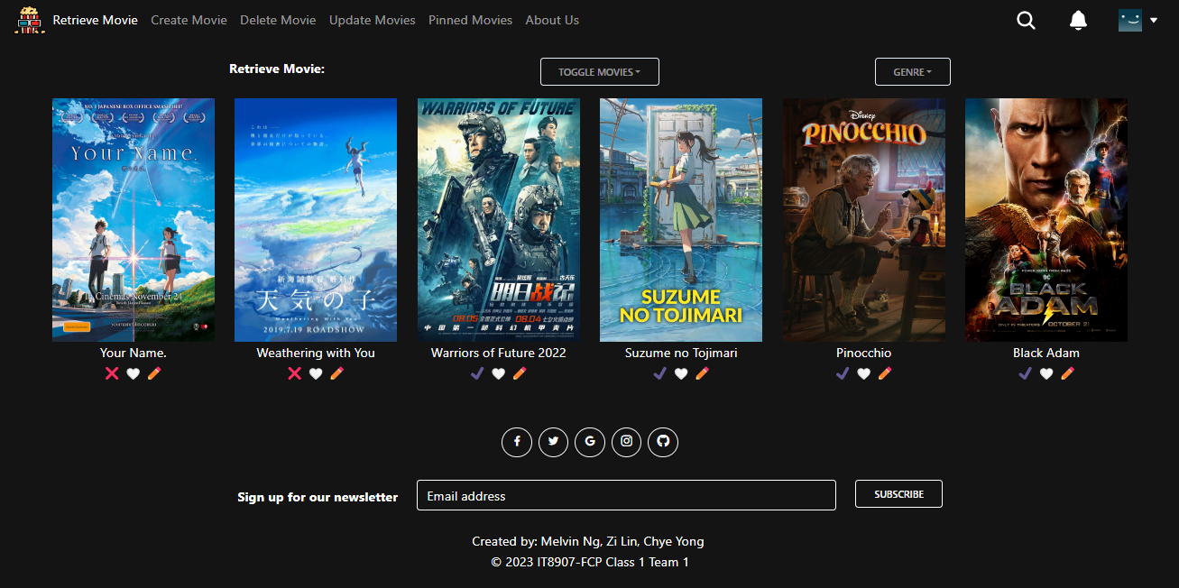After Sorting Z-A:

1. **Function #5 - Retrieve Movies and Sorting A to Z**

* Once the user is logged in, the user can use this function to retrieve the latest movies database from the server and display it in alphabetical order (A to Z).

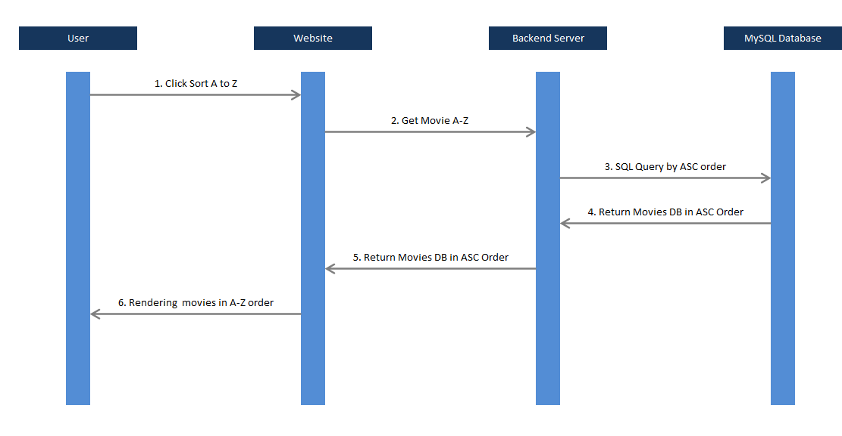

* Before Sorting A-Z:



* 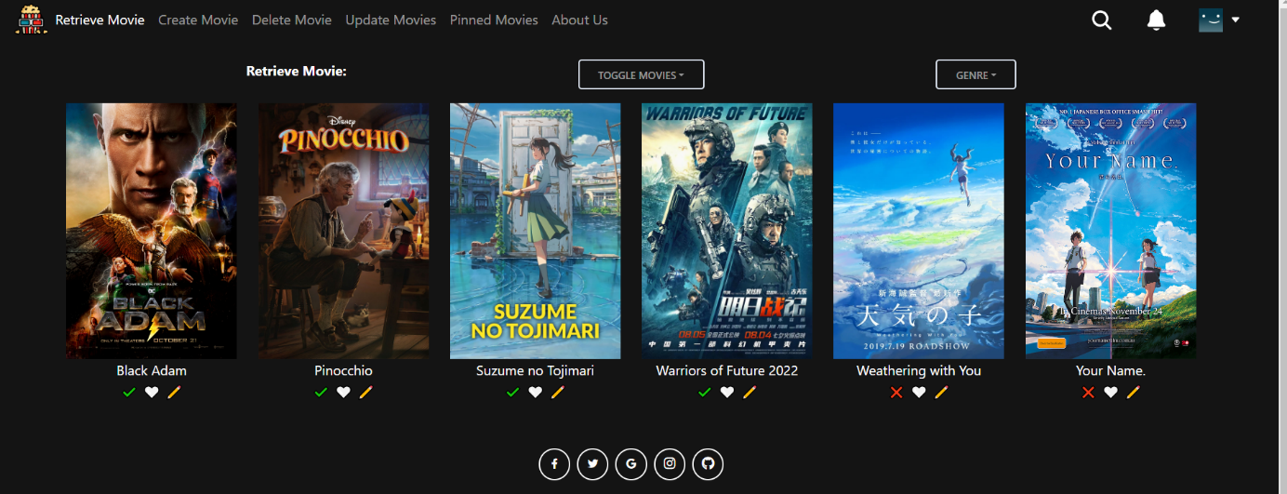After Sorting A-Z:

...

## Technology

*A listing and brief description of the underlying frameworks / libraries used by the application.*

## Development Tools and Processes

*This section should be used to document:*

* *any specific development tools, compilers or suggested IDEs that are used for the application.*
* *Describe how software source control is performed (e.g. Git)*

## Interfaces and services

* List all backend interfaces (incoming – data into the backend, outgoing – data out of the backend) and the path to the file (and lines of code) in which they are stored in.

| **Function Integrated** | **Details of Front End Codes** |  | **Details of Back End Codes** |
| --- | --- | --- | --- |
| Function #1 | Function.jsx (lines 20 to 30) | <-> | App.js (lines 10 to 15) |
| Function #4  (Retrieve & Sorting Z to A) | src/components/RootPage/Index.jsx  (lines 19-24 , 96-98 , 116-118) | <-> | controller/app.js  (lines 183-193) |
| src/redux/movieSlice.js  (lines 62-79 , 112-128) | model/movie.js  (lines 180-202) |
| src/utils/functions.js  (lines 439-461) |  |
| Function #5  (Retrieve & Sorting A to Z) | Src/components/RootPage/Index.jsx (lines 19-24, 88-90, 105-107) |  | controller/App.js (lines 171-181) |
| Src/redux/movieSlice.js (lines 44-60, 92-107) |  | model/movie.js  (lines 27-50) |
| Src/utils/functions.js (lines 404-432) |  |  |
|  |  |  |  |

# APPENDIX

A brief description of what the additional / advanced features that were added in as well (beyond the scope of the CA1/CA2 requirements)

## Additional / Advanced features

High level description of what other additional / advanced functionalities the system contains.

This should include

i) a general description of the functionality in words.

ii) screenshots demonstrating how the functionality works (i.e. what would be observed by the User)

## Reference Links

For additional information, please kindly refer to the following links below:

GitHub Repository Link : <https://github.com/SP-CET-Capstone/capstone-assignment-class-1-team-1>

Our group’s README.md: <https://github.com/SP-CET-Capstone/capstone-assignment-class-1-team-1/blob/main/README.md>

Our group’s Kanban Board: <https://github.com/orgs/SP-CET-Capstone/projects/11>

Roles & Responsibilities of each team member (we worked together like a Scrum team): <https://github.com/orgs/SP-CET-Capstone/projects/11?pane=issue&itemId=19145533>